**HW1 - Project Group 1**

**Eli Goodwin**

**Andrew Lodge**

**Robert Scanlon**

**Kevin Lewis**

**Requirements definition:**

**Functional Requirements:**

The program will allow inmates to improve their education and or develop new skills for a future career, their current job, hobbies they are interested in and or improve their current set of life skills using popular computer based learning websites such as Coursera, Udemy, Udacity, etc as a model. What makes this program different though is that it will be made of strictly offline resources due to security concerns given the user base.

Users will create an account which is used to track their learning module purchases, their learning progress, balance in their resource currency wallet, and will be used to store their skill assessment profile. Once a user creates an account they will be given an initial amount of resource currency that will be used to purchase learning resources. Currency used to purchase modules does not have monetary value and is given to users for positive behavior and small amounts are returned to users once they have completed a learning module incentivizing completion of courses.

Users will take an assessment gauging their current strengths, weaknesses and aptitude, similar to the ASVAB. Users will also take a brief survey indicating what kind of hobbies they have. Following completion of their assessment and survey a user profile will be created so that learning resources will be curated to their interests and strengths. With the assessment complete and a user profile created, the user will now have access to the learning resource store.

The learning resource store allows users to purchase learning resources using resource currency in their wallet. A user will be initially presented with three categories to chose from: hobbies, job/career skills, and life skills. Once a user selects a category they will be presented with a list of resources presented in correlation to their assessment and interests--those of high correlation are presented first, those with lower correlation are presented last. All learning resources in the life skills category would be free of cost.

Once a user finds a learning resource they wish to purchase they will be able to add it to their cart or save it to their wishlist for future purchase. When the user is ready to checkout they will be asked to review their cart before finalizing their purchase. Once finalized the learning resources will be added to learning path and available for immediate access.

Learning resources would vary in format depending on the content—some would be made of video lectures, some would be of readings available as PDF, while others would be combination of the two. Common to all courses would be a notebook the user would be able to use take notes while viewing readings or lectures. Users would be evaluated on their mastery of the content by completing quizzes on the material they are presented in the form of repeatable automated quizzes. As a user progresses through their curriculum they would be presented with achievements for completing subtasks in a learning module and completing of a learning module.

As mentioned previously, once a user completes a learning module they would be refunded a partial amount for what they spent on the learning module incentivizing completion of learning materials and to encourage good behavior. At this point, users would be able to access and purchase the next iteration of completed modules or start new recommended modules.

**Non Functional Requirements:**

The program must have high compatibility with limited hardware requirements given that the end users are in prisons on likely dated hardware and or obsolete hardware. System must run efficiently and smoothly on dated hardware. New users and hardware must be able to be added to the system without significant performance impact. Users must not have access to outside networks to while using the program. The program must run with little maintenance as end users will not be able to troubleshoot software problems. If required, maintenance of system should only require basic software skills for most required actions. System shall be backed up to external storage at regular intervals so that recovery can occur with minimal impact.

**Use Case Name: Assessment Test**

Actors:

* User (has an existing account created for him/her)
* User System
* Assessment System
* Profile System
* Content Provider
* Prison Staff

Pre-Conditions:

* User has not taken assessment test (first time user)

Post-Conditions:

* The user will have an assessment profile.
* The user will have a learning profile.

Typical Scenario:

1. User logs into the system and credentials are validated
2. Profile system indicates it has not been created
3. User is prompted to take the assessment test.
4. User indicates he or she is ready and begins the test.
5. System presents questions in the following format:
   1. Multiple Choice
   2. Arithmetic / Math (Answer must be manually typed In)
   3. True / False
6. User answers questions appropriately
7. Assessment system processes answer
8. Assessment system presents new question dependent on accuracy of previous question.
9. Steps 5 - 7 are repeated until the test is completed.
10. Assessment analyzes all test questions / answers
11. Assessment system provides the Profile system with results
12. Profile system indicates that the test is completed.
13. User system indicates that the user’s answers have been processed and the results are ready to be viewed.
14. The user exits the system.

**State Chart: Assessment Test**

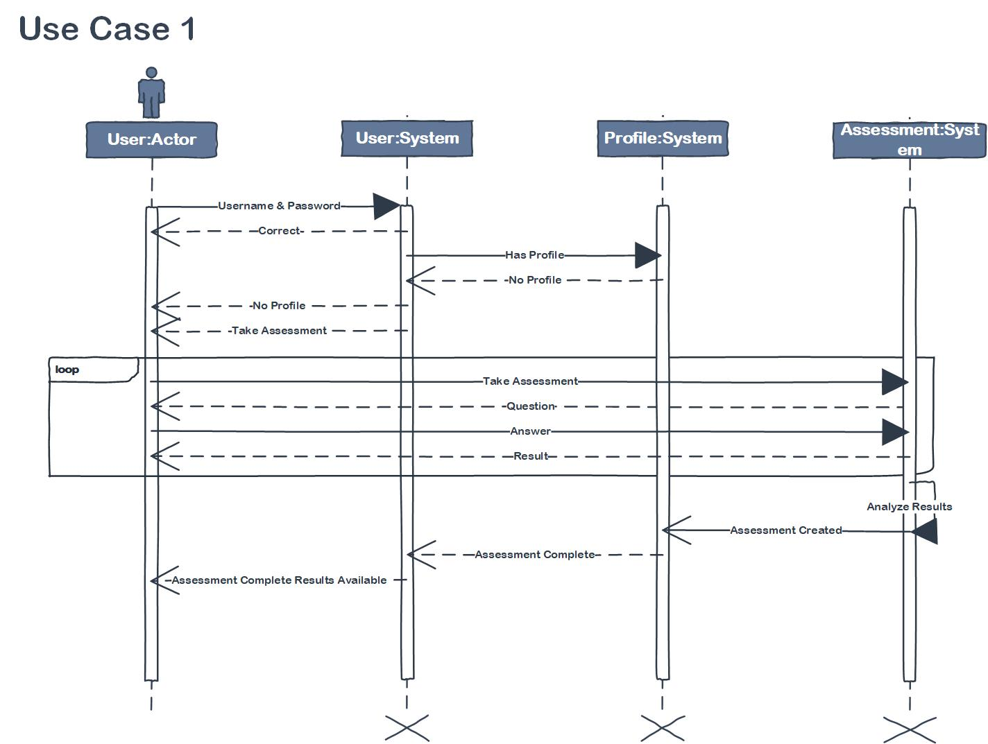

**Use Case Name: Resource Store**

Actors:

* User (User has taken assessment)
* User Object
* Assessment Results (created from the assessment)
* Resource Store (contains resources to build on various skills)
* Learning Modules (learning resources that a user can purchase)
* Content Provider
* Prison Staff

Pre Conditions:

* User has taken the skills and knowledge assessment.
* Results of assessment must correlate to resources the user can utilize in the resource store.
* User must have resource credits to spend unless they are browsing free content.

Typical Scenario 1: New user browsing and purchasing from the resource store:

1. User enters resource store.
2. User is given credits to purchase resources from the resource store post assessment.
3. User selects the type of resource they are looking for.
4. Once the user selects the type of resource they are looking from the CJH menu resources populate according to correlation with their skill assessment and availability--results of high correlation appear first, those with little correlation follow next, while those that are available in the future following completion of prerequisites appear last.
5. User browses resource store and is able to purchase resources or add resources of interest to their wish list for future purchase. Items that are to be purchased are added to shopping cart and those that are wishlisted are saved for future sessions.
6. Once user is done browsing and adding items to their cart, they hit a checkout button taking them through pre-checkout.
7. During pre-checkout the user is asked to review their shopping cart of resources and validate selections. Cart is displayed as a list of resources on the left side of the list with prices on the right side of the list.
8. User authorizes transaction and spending of credits on resources, finalizing checkout.
9. User purchased resources are then added to their learning plan.

Typical Scenario 2: Returning user browsing and purchasing from the resource store:

1. User enters resource store.
2. User resource credit balance is verified and their wallet is loaded.
3. User selects the type of resource they are looking for or can browse modules currently in their wishlist.
4. The remaining steps are the same as the previous scenario starting from step 5.

**State Chart: Resource Store - Scenario 1**

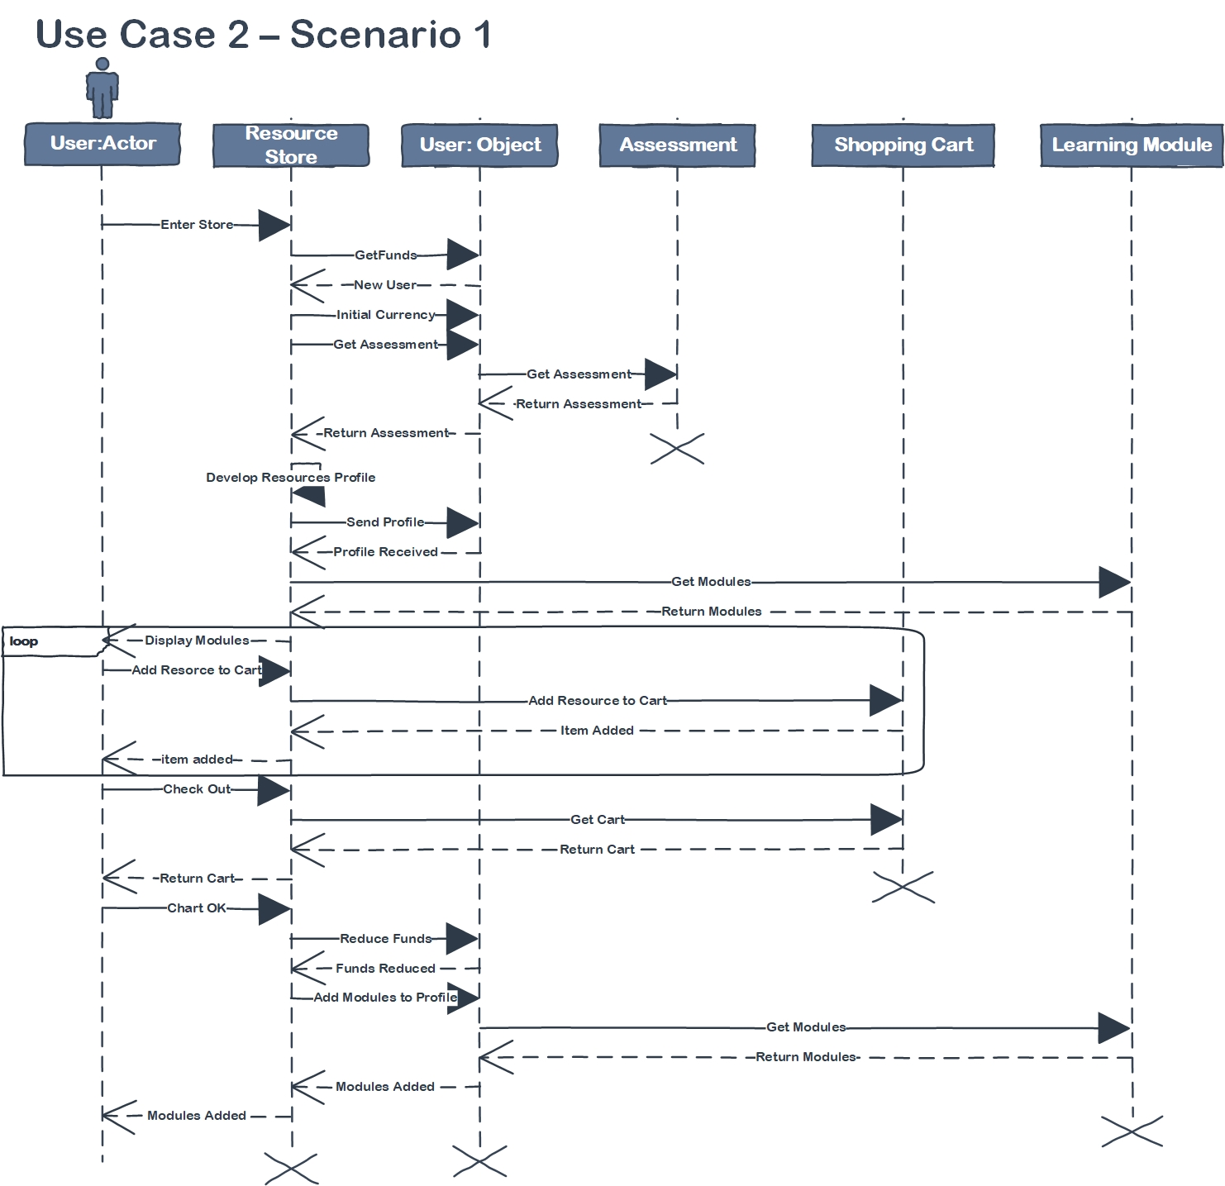

**State Chart: Resource Store - Scenario 2**

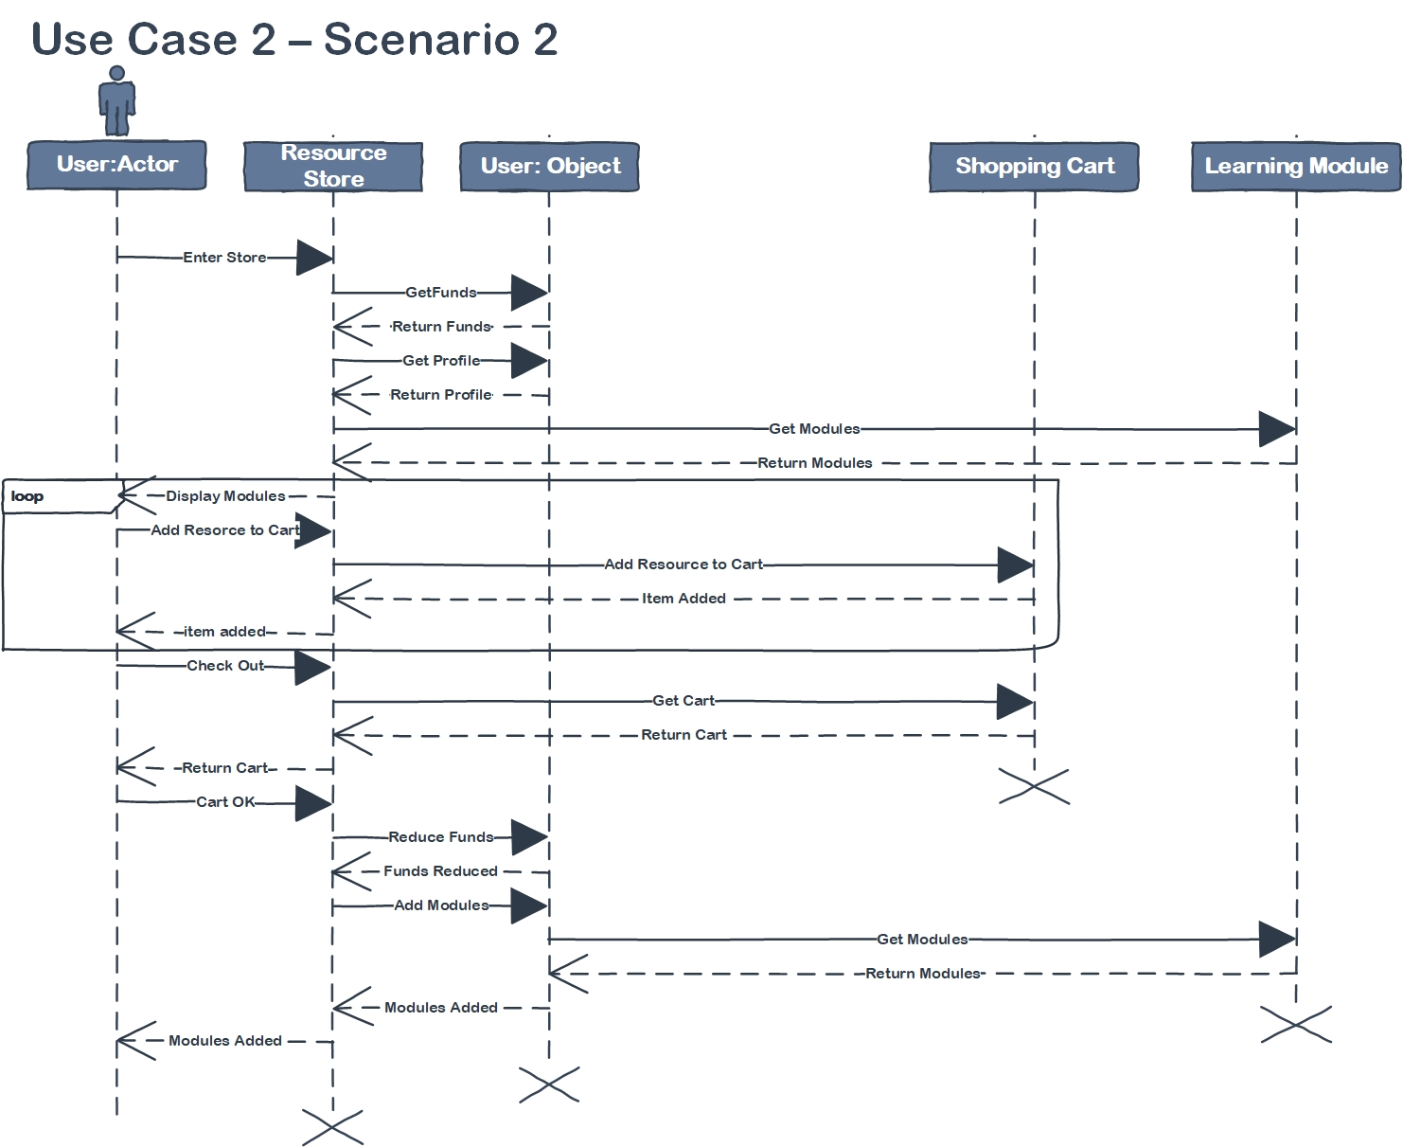

**Use Case Name: Learning**

Actors:

* User (has purchased learning resources which are saved in their account)
* Purchased Resources (resources are used to create learning paths)
* Learning Module
* Reading
* Lecture
* Quiz

Pre Conditions:

* User has purchased learning resources

Post Conditions:

* User has completed the learning module including the provided quiz.
* Quiz results are stored in the user’s profile.

Typical Scenario:

1. User navigates to their learning plan, containing purchased modules.
2. The user selects the module they wish to begin.
3. The user is presented with their selected module’s homepage containing links to all reading material and video lectures.
4. The user selects the reading or lecture they wish to study.
5. The material is then presented to the user in the browser. Readings are presented in standard web-page format; videos are presented within an in-browser media player containing controls to play and pause, as well as a video scrub bar.
6. While viewing the learning material, the user may select the notebook icon and add or edit a notebook entry.
7. When done reviewing the material, the user navigates back to the module home page.
8. The user may then select the module’s quiz which will direct them to the quiz page.
9. The user is presented with a set of questions followed by multiple choice answers.
10. The user selects the appropriate answer for each quiz question.
11. When satisfied with their answers, the user submits the quiz.
12. The user’s score is then recorded in the user’s profile and presented to the user.
13. The user is given the options to retake the quiz, or return the the module’s main page.
14. The user chooses to return to the main page and check their learning progress.
15. After reviewing their progress the user logs out of the system.

**State Chart: Learning - Part 1**

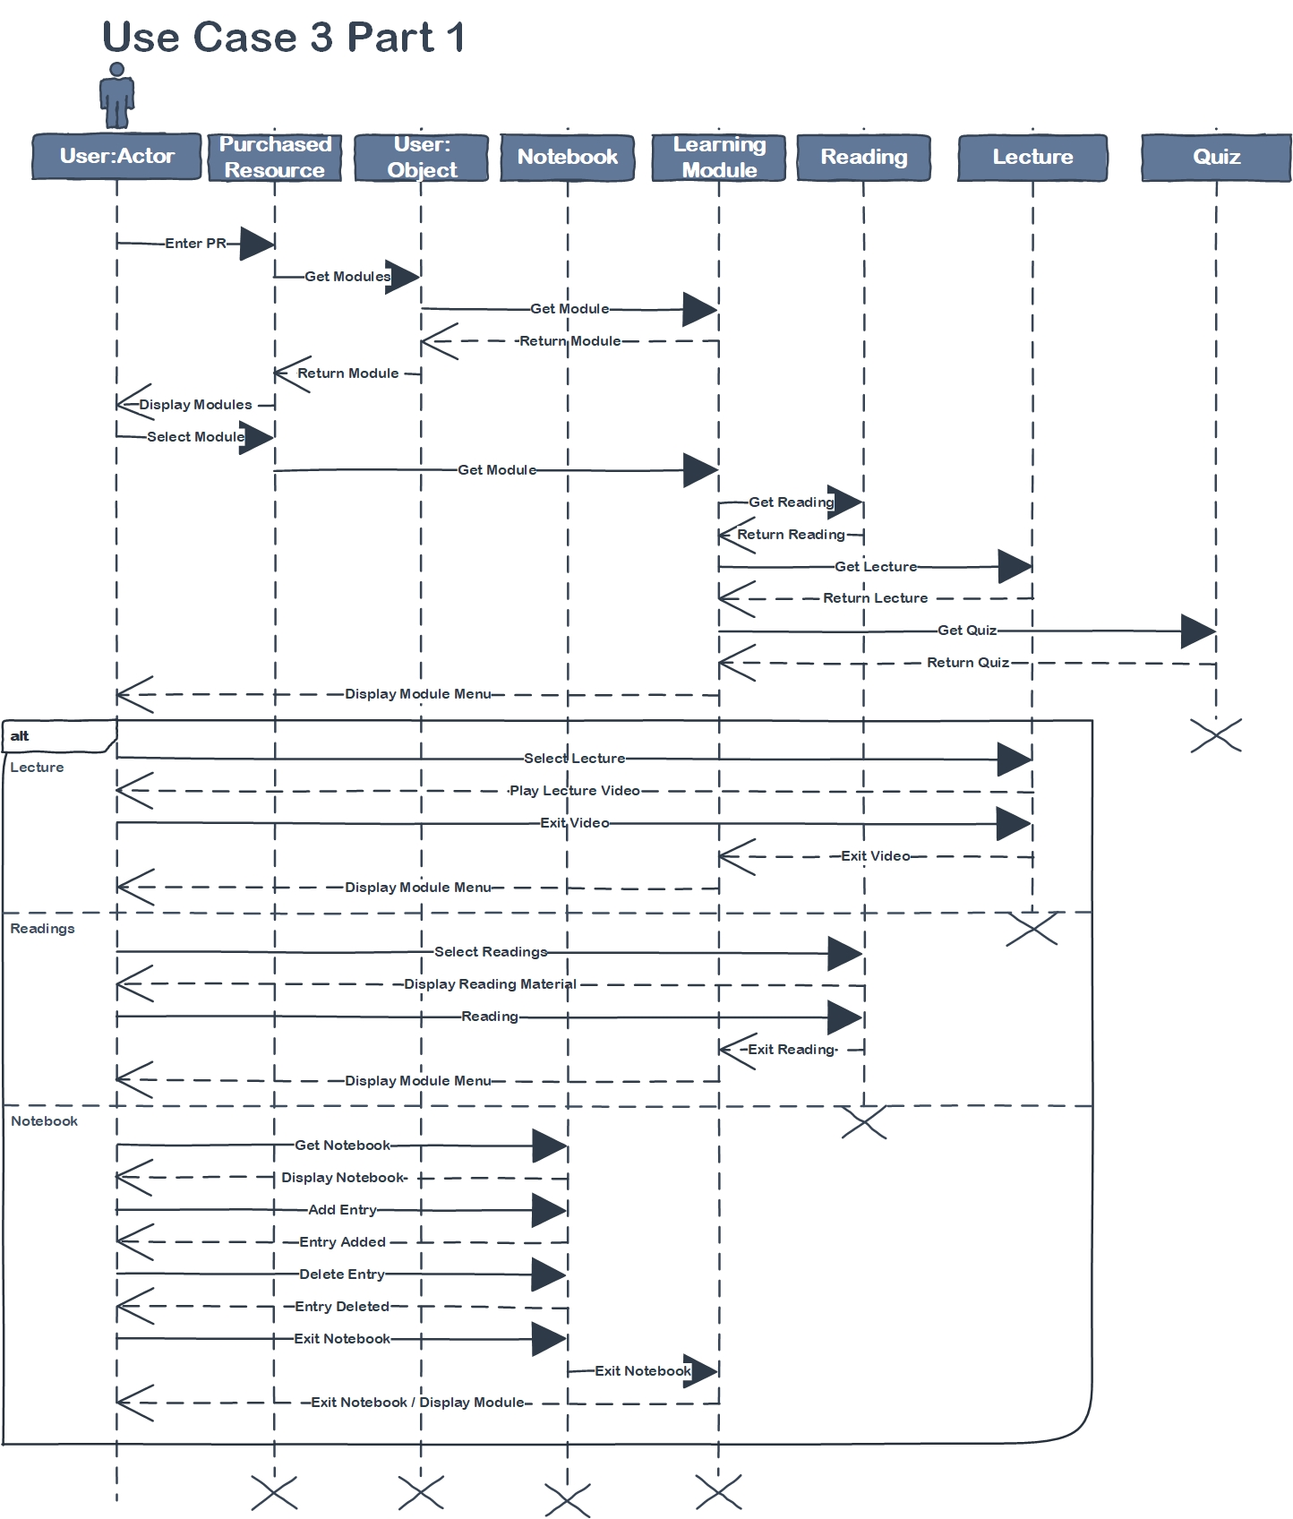

**State Chart: Learning - Part 2**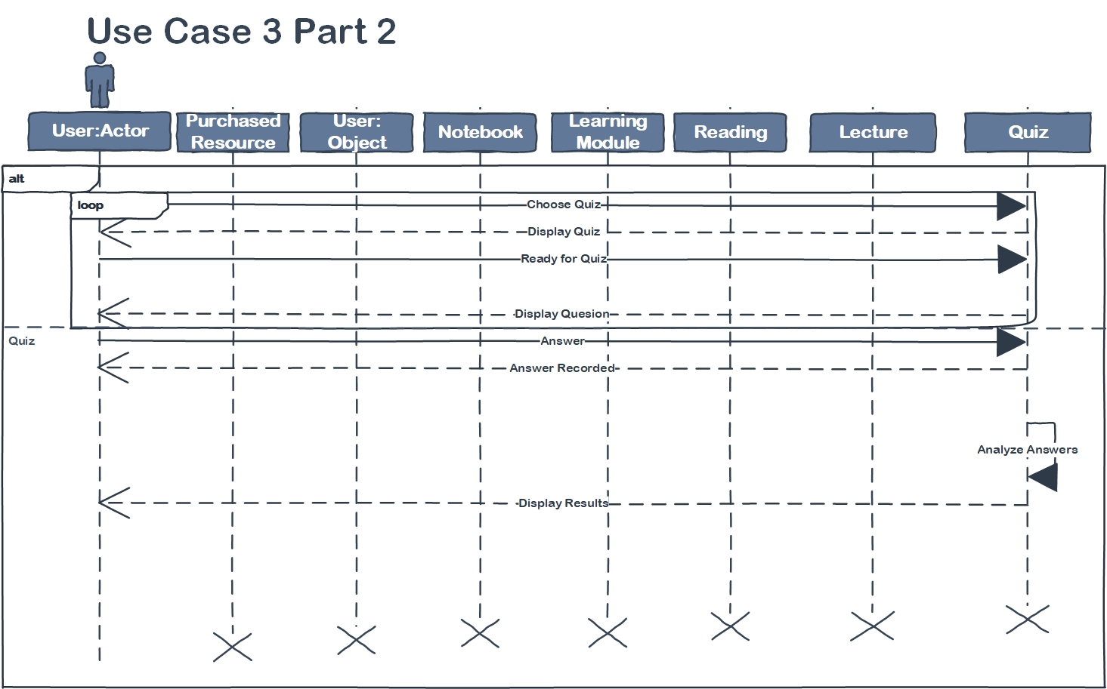

**Important Entities (UML)**

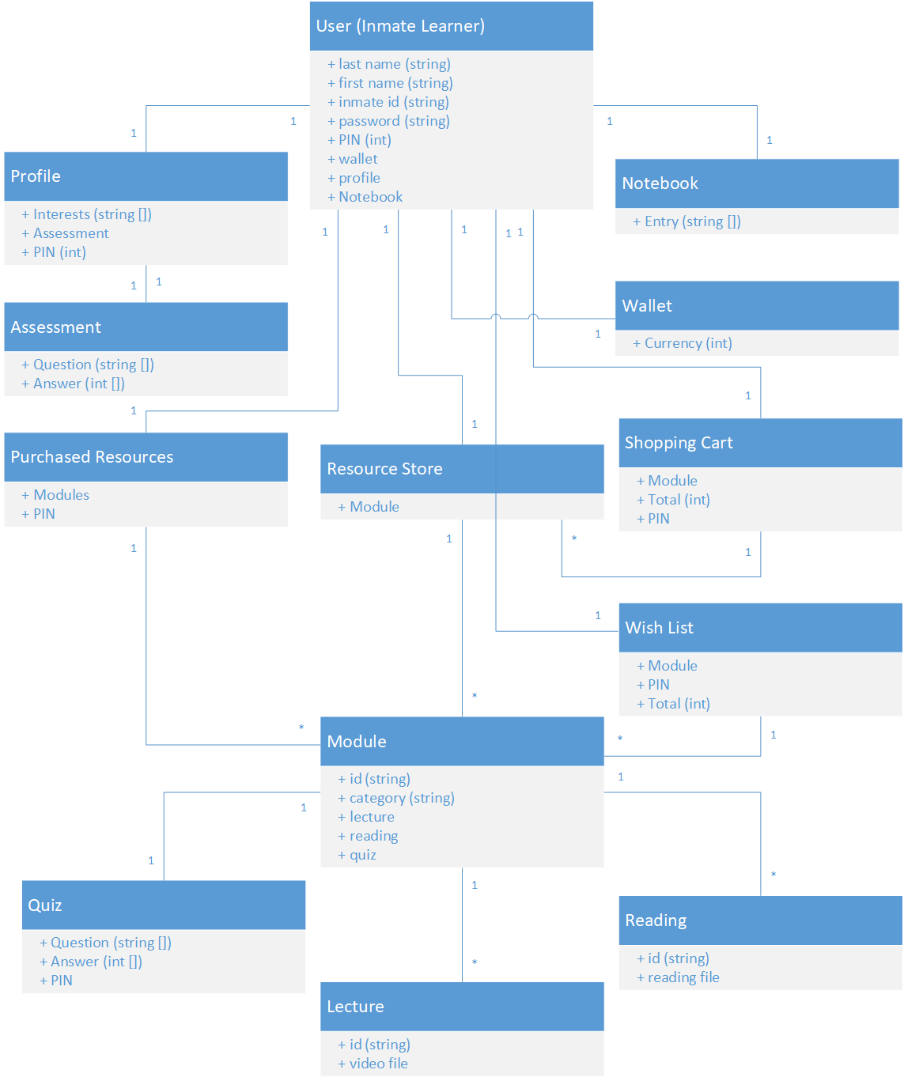

**Requirements Specification:**

**Functional Specifications:**

* The program will be a local webapp on a local private network and server,
* All user data and learning content will be stored in a database managed by the local server. Due to security risks, users will use the web app on machines that have access to the local private network and with no other network access.
* Users will login into their account and this will give them access to their learning modules and the learning module store.
* Users will be able to select which language to use to interact with the system. Users will be able to select which language(s) they want to see available content in. (i.e. a bilingual user may select their preferred language to use to interact with the system, but see available content in both of his/her spoken languages.
* App navigation will be much like using a normal interactive webpage. A control menu will be on the left hand side of the screen allowing them to access other parts of the app, like their current learning path, the learning module store, their assessment results, modules, wish list, wallet balance, etc. Users will not be able to alter their logon credentials
* At all times there will be a notebook drop down pane on the right side of the screen that will allow users to access their notebook in page without leaving the current page. Users will be able to add folders and notes to the notebook to organize their thoughts regarding their current materials.
* Prison staff will be able to monitor learning progress and also be able to add currency to users’ wallets as a reward system within the broader prison structure.
* All learning will be mediated through the web app—readings, lectures, quizzes, and note taking etc.
* All course material stays on the servers. There are no take aways.

**Non-functional Specifications:**

* The server will have a MySQL database that will contain all necessary user data, learning materials and will be managed by an administrator.
* To maximize compatibility with minimum hardware specs the web app will target Internet Explorer 8 for that is the last native browser supported by Windows XP which is likely the operating system running on end user’s machines.
* The Local server will be air gapped from all other networks besides the local network during normal use. If updates are to occur the local server will be air gapped from the local network ensuring that it is not possible for inmates to access outside networks.

**Data Flow Diagram - Learning**

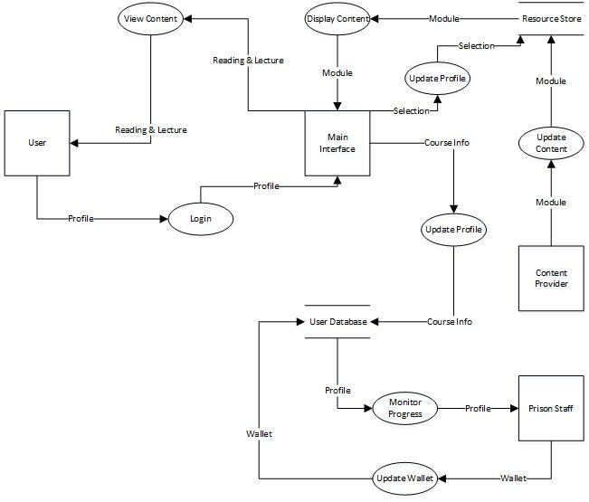

**Data Flow Diagram - Resource Store**

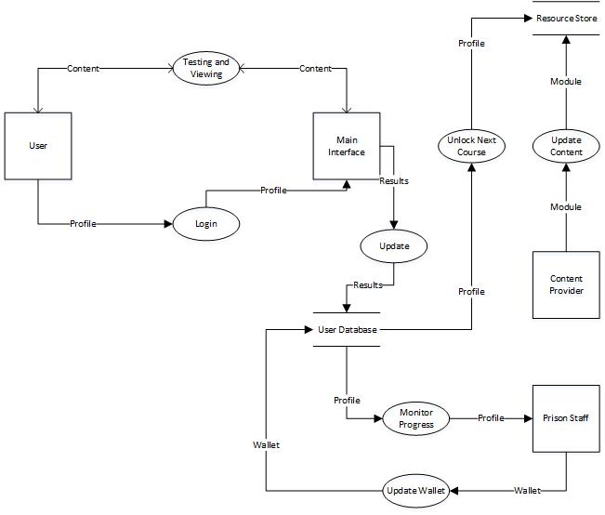

**Data Flow Diagram - Assessment Test**

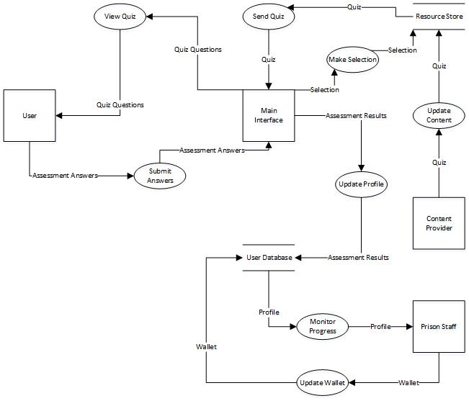

**Customer:**

We communicated with the customer via e-mail on October 9th. Customer provided some feedback and expanded upon the vision statement and gave specific requirements not in the vision statement.

**Group Participation:**

* Eli Goodwin
  + Description of functional and nonfunctional requirements.
  + Structured description of 2nd use case.
* Andrew Lodge
  + Data flow Diagrams
* Robert Scanlon
  + UML Class Diagram
* Kevin Lewis
  + Structured Description of 1st use case.
  + Message Sequence Charts.